

MANAGING OUR PERFORMANCE
END OF YEAR
REPORT
2015/16

June 2016

Planning & Performance

CONTENTS

 |  | Page
1 | Executive Summary | 3
2 | Introduction | 4
3 | 2015/16 HEAT Standards | 6
 | HEAT Summary of Performance | 6
 | Monthly Performance and Narrative of HEAT Standards | 8
 | Summary of Overall Performance: April 2015 - March 2016 | 24
 | Progress on Targets Not Reported on a Monthly Basis | 25
4 | Update on Contributions to Single Outcome Agreement | 29
 | A summary of the performance of a number of selected contributions which are related to the Single Outcome Agreement
5 | Corporate Objectives | 31
- EXECUTIVE SUMMARY

Background

For a number of years, NHS Borders Board has reviewed the performance of the organisation at each Board meeting and this has been facilitated through the production of performance reports showing progress towards achievement of the range of national targets set through the local delivery plan process. In addition to the reports, the Managing Our Performance (MOP) report has been reviewed by the Board to assess performance across the full range of targets and indicators at the mid way point and also at the end of each financial year.

2015/16 End of Year MOP

This 2015/16 End of Year MOP Report includes an assessment of performance in relation to the HEAT standards, contributions to the Single Outcome Agreement and Corporate Objectives. This report shows trends for each target which can be reported on monthly, along with narrative describing progress made this year. As in previous versions, an update is included on the full range of HEAT standards, including those which cannot be reported on a monthly basis and are therefore not included in the HEAT Scorecard. A RAG status has been applied to those targets not reported on a monthly basis and is based on performance at the end of March 2016.

Summary

This report allows Board members to see the final position for 2015/16 and assess what action is required going into 2016/17 to ensure continuous delivery of the full range of HEAT standards.

- INTRODUCTION

The Local Delivery Plan

Every year the Scottish Government Health Department (SGHD) asks each Health Board to report to them on their performance and delivery plans for the next financial year. This report is called the Local Delivery Plan (LDP) and forms an agreement on what Health Boards will achieve in the next year with SGHD. Boards are asked to work towards a number of key standards for the year which fit with the Government’s health objectives.

Monitoring of Performance

For each Clinical Board (Primary, Acute and Community Services, Mental Health and Learning Disability Service) a monthly Performance Scorecard is produced which includes an assessment of performance towards achievement of the HEAT standards along with a range of locally set key performance indicators (KPIs). These 3 Scorecards are compiled into the Integrated Performance Report which is presented to the Clinical Executive Operational Group on a bi-monthly basis.

At the Clinical Executive Operational Group discussions take place around the areas where performance is significantly off track and information is also provided with the Scorecard on action being taken to improve performance.

In addition to this reporting, each Clinical Board attends a quarterly performance review where performance is monitored by the Board Executive Team and a quarterly Clinical Board Scorecard is reviewed.

Information is taken from the monthly Clinical Board Performance Scorecards to compile the HEAT Scorecard which is reviewed by NHS Borders Board at each Board meeting (bi-monthly). The HEAT Scorecard provides information on all targets and standards which can be reported on monthly and indicates whether performance is in line with agreed trajectories for each month of the year. The locally set KPIs are reviewed by the Strategy & Performance Committee in a similar fashion through the Integrated Performance Report when they meet on a bi-monthly basis.

2015/16 HEAT Standards

This 2015/16 End of Year MOP Report summarises performance for all HEAT standards from April 2015 to March 2016 that can be reported monthly, and a trend graph and narrative is included for these. For standards which are not reported on a monthly basis Lead Managers have provided narrative to indicate whether they are on track for delivery and if not, to highlight planned actions.

Single Outcome Agreement & Corporate Objectives

In section 4 and 5, information is included on planned work on the Single Outcome Agreement with local partners such as Scottish Borders Council and there is a summary of progress towards embedding the Corporate Objectives.

Please note:

- Some anomalies may occur in data due to time lags in data availability and national reporting schedules.

- 2015/16 HEAT TARGETS

Summary of Performance

Strong Performance – Green targets

The following targets are meeting or have exceeded their trajectories or standards at the end of March 2016:

- Smoking cessation – latest available data December 2015 (page 8)
- Pre Operative stay (page 9)
- Online triage of referrals (page 10)
- Treatment within 62 days for urgent referrals of suspicion of cancer (page 13)
- Treatment within 31 days of decision to treat for all patients diagnosed with cancer (page 13)
- 18 weeks referral to treatment: non-admitted pathway performance (page 15)
- 18 weeks referral to treatment: combined performance (page 16)
- 90% of alcohol/drug referrals into treatment within 3 weeks (page 20)
- Emergency Occupied Bed Days for the over 75s (page 22)
- Admission to the Stroke Unit with 1 day of admission (page 23)

Performance at Risk – Amber targets

Performance against the following standards was outwith the trajectory at the end of March 2016:

- New patient DNA rate (page 8)
- Day case rates (page 9)
- Exclusive breastfeeding rate at 6-8 weeks check, local data (page 10)
- eKSF annual reviews completed (page 11)
- 18 weeks RTT: admitted pathway performance (page 15)
- Diagnosis of dementia (page 20)
- 4 hour waiting target for A&E (page 22)

Under Performing – Red targets

Performance was significantly outwith target for the following HEAT standards at the end of March 2016:

- PDPs complete on eKSF (page 11)
- Sickness absence reduced (page 12)
- 12 weeks for outpatients (page 14)
- 12 weeks for inpatients (page 14)
- 4 weeks waiting target for diagnostics (page 17)
- No CAMHS waits over 18 weeks (page 18)
- No psychological therapy waits over 18 weeks (page 19)
- No delayed discharges over 2 weeks (page 21)

Further information on all the HEAT standards are detailed within the report and have been given a RAG (Red, Amber, Green) status based on the following key:

Current Performance Key
R | Under Performing | Current performance is significantly outwith the trajectory set. | Exceeds the standard by 11% or greater
A | Slightly Below Trajectory | Current performance is moderately outwith the trajectory set. | Exceeds the standard by up to 10%
G | Meeting Trajectory | Current performance matches or exceeds the trajectory set | Matches or exceeds the standard.

Monthly Performance and Narrative of HEAT Standards
(Please note time lag in data availability for some areas)

Standard: Smoking cessation successful quits in most deprived areas (cumulative) | 2015/16 Standard | Current Standard | Year End Position | March 2016 Status
 | 117 | 72  (Dec 15) | 96  (Dec 15) | G
Please Note: Data will be reported quarterly with a 4 month lag time to allow monitoring of the 12 week quit period. | The Smoking Cessation standard has been achieved for the first 3 quarters of 2015/16 however due to the lag time in data for monitoring the 12 week quit period the final end of year position is not yet available.  Additional Specialist Smoking Cessation Advisor capacity has been deployed during 2015/16 to support meeting this target. There has been a refocusing of service delivery to support the most deprived areas. The rise in quit rates reflects this and the end of year rate is expected to be above the standard.  There has also been focussed work to increase referrals to smoking cessation support from the BGH. Supporting more pregnant women to stop smoking has also been a priority throughout 2015/16.

Standard: New patients DNA rate will be less than 4% over the year | 2015/16 Standard | Current Standard | Year End Position | March 2016 Status
 | 4% | 4% | 4.2% | A
There has been an improvement in the management of missed appointments during 2015/16.

This follows a drive to improve the maintenance from patients of up to date contact details, and contacting patients who have failed to attend appointments in the past a few days before the scheduled appointment.

Standard: 86% of patients for day procedures to be treated as Day Cases | 2015/16 Standard | Current Standard | Year End Position | February 2016 Status
 | 86% | 86% | 84.4%  (Feb 16) | A
Please Note: There is a 2 month lag time due to SMR reporting | Day case procedures as a percentage of all procedures remain slightly below target.  NHS Borders is currently redesigning theatres and surgical flow with the Institute of Healthcare Optimisation. It is anticipated that this work will enable the repatriation of waiting times activity which should increase the number of day case procedures carried out locally.

Standard: Reduce the days for pre-operative stay | 2015/16 Standard | Current Standard | Year End Position | February 2016 Status
Standard: Reduce the days for pre-operative stay | 0.47 | 0.47 | 0.21  (Feb 16) | G
Please Note: There is a 2 month lag time due to SMR reporting | Performance on admissions the day before the procedure is exceeding the current target. The highest admissions the day before the patients procedure is in orthopaedics. Further work through the redesign of theatres and surgical flow in 2016/17 should reduce the number of patients admitted the night before their procedure.

Standard: 90% of all referrals to be triaged online | 2015/16 Standard | Current Standard | Year End Position | March 2016 Status
Standard: 90% of all referrals to be triaged online | 90% | 90% | 93.9% | G
The target of 90% has been consistently achieved throughout 2015/16 and is expected to continue during 2016/17.

Performance for January 2014 has been rerun and reports 93%, therefore achieving the target. The data is a snapshot in time, records have been updated since the original run and therefore not included within the performance report.

Standard: Increase the proportion of new-born children breastfed at 6-8 weeks | 2015/16 Standard | Current Standard | Year End Position | September 2015 Status
 | 33% | 33% | 32.0%  (Sept 15) | A
Please Note: There is a 3 month time lag as data is published quarterly for this target. Local data is used due to the extended time lag for national data. | The services continue to work collaboratively with health improvement. We appointed to the BFI Lead post in August 2015 and have developed the following in 2015/16;  - A whole town approach to breast feeding in Selkirk through improvement methodology.  - A drop in breastfeeding clinics in Early Years Centre.  - Continuing to deliver training and updates to all staff.  - To maintain/continuing to improve performance we have increased the provision of peer supporters  - Peer supporters working within Early Years Assessment team  - Focus on improving breast feeding rates within Special Care Baby Unit.

Standards: | 2015/16 Standard | Current Standard | Year End Position | March 2016 Status
80% of all Joint Development Reviews to be recorded on eKSF | 80% | 80% | 73.1% | A
80% of all Personal Development Plans to be recorded on eKSF | 80% | 80% | 61.6% | R
Joint Development Reviews recorded on eKSF  Personal Development Plans recorded on eKSF | Overall NHS Borders has failed to achieve the standards over the period April 2015 to March 2016 which has brought the overall rate below 80%. Reasons highlighted for this include requirement to focus on clinical priorities preventing staff updating eKSF, therefore although quality conversations took place, and PDP’s completed these haven’t always been updated on eKSF.  There has been inconsistency across local reports identified, with clinical boards using different permanent staff baseline figures. An agreement has been made that local reports should reflect national baseline figure and updated figures were sent out. Looking ahead – these will be communicated to KSF Champions every 3 months to ensure accuracy of Permanent Staff in post numbers.  KSF Champions are requesting trajectories from Line Managers now for coming year. Performance against local trajectories is monitored through Clinical Boards in their Performance Scorecards to ensure we continue to work towards standard. Training continues to be available from KSF Champions. The Employee Director is the Executive Lead and will support KSF Champions and report back to Board Executive Team on a regular basis.

Standard: Maintain Sickness Absence Rates below 4% | 2015/16 Standard | Current Standard | Year End Position | March 2016 Status
Standard: Maintain Sickness Absence Rates below 4% | 4% | 4% | 5.4% | R
Cumulative sickness absence for year April 2015 – March 2016 is 4.36% - which is 0.80% lower than the NHS Scotland Average and is the lowest year end figure of the territorial boards and 0.35% lower than last year.

There are issues around the accuracy of data, managers record sickness absences on SSTS however this is not always completed within the appropriate timescales by line managers and therefore the information is not as accurate as it should be. HR have made Clinical Boards aware of data quality issues and the Finance department also send out monthly email reminders to SSTS users to ask that all long term absences are recorded on the system by a specific date.

HR also provide advice and support to managers to help manage sickness absence levels in line with the policy however the advice is not always acted on. HR are working together with Work and Well Being Services and line managers to manage long term sickness absence and have noted a number of ill health retirements/dismissals due to capability health reasons.

HR continue to be a support service to the clinical boards by providing HR advice and support in managing sickness absence, HR will recommend actions to be taken in line with the NHS Borders Sickness Absence Policy. HR also provide monthly sickness absence reports to each Clinical Board, these detail the level of short term and long term sickness absence levels in each department, provide the trends and the reasons for sickness absence. HR also proactively identify sickness absence “hot spots” and contact managers to enquire if any support is required in managing levels.

Managers are also required to complete a mandatory sickness absence e-learning module, attend a sickness absence training course and a refresher course.

HR are continuing to work alongside Work and Wellbeing Services to provide advice and support to line managers to manage sickness absence levels. HR are continuing to revise sickness absence processes to ensure we are providing an efficient and supportive service to managers. Correspondence to managers indicating if employees are not meeting the expected level of attendance is being revised to indicate that action is recommended/required as well as reminding managers of actions that could / should be taken.

Standard: 95% of all cases with a Suspicion of Cancer to be seen within 62 days | 2015/16 Standard | Current Standard | Year End Position | March 2016 Status
 | 95% | 95% | 100% | G
NHS Borders met the national target of 95% for each quarter during 2015/16.

There remain some issues around patients requiring treatment in NHS Lothian, particularly for those waiting for specialised surgery. This is due to an increased demand within the Prostate and Lung surgical patients and patients that require Prostate Brachytherapy as at present NHS Lothian only provide 2 slots per week that is to treat referred patients from other boards.

Standard: 95% of all patients requiring Treatment for Cancer to be seen within 31 days | 2015/16 Standard | Current Standard | Year End Position | March 2016 Status
 | 95% | 95% | 100% | G
NHS Borders met the national target of 95% for each quarter during 2015/16.

There remain some issues around patients requiring treatment in NHS Lothian, particularly for those waiting for specialised surgery. This is due to an increased demand within the Prostate and Lung surgical patients and patients that require Prostate Brachytherapy as at present NHS Lothian only provide 2 slots per week that is to treat referred patients from other boards.

Standard: 12 wks for Outpatients | 2015/16 Standard | Current Standard | Year End Position | March 2016 Status
Standard: 12 wks for Outpatients | 0 | 0 | 258 | R
Significant progress has been made around Outpatient Waiting Times during 2015/16, with the majority of specialties now booking within 12 weeks.

There remain significant challenges within ENT, Gastroenterology and Chronic Pain.

Standard: 12 wks for Inpatients | 2015/16 Standard | Current Standard | Year End Position | March 2016 Status
Standard: 12 wks for Inpatients | 0 | 0 | 10 | R
Significant progress has been made around Inpatient Waiting Times during 2015/16, with all Specialties now booking within 12-weeks.

All patients currently reported as breaches have been as a result of short-notice cancellations which continues to remain a risk.

Standard: 18 Weeks Referral to Treatment Admitted Pathway Performance | 2015/16 Standard | Current Standard | Year End Position | March 2016 Status
 | 90% | 90% | 82.8% | A
 | 18 Weeks Referral to Treatment admitted pathway performance has made significant improved during the year, although this has not yet reached 90%.

Standard: 18 Weeks Referral to Treatment Non-Admitted Pathway Performance | 2015/16 Standard | Current Standard | Year End Position | March 2016 Status
 | 90% | 90% | 94.9% | G
 | 18 Weeks Referral to Treatment non-admitted pathway performance has remained relatively static over the past year, consistently above the 90% standard.

Standard: 18 Weeks Referral to Treatment Combined Performance | 2015/16 Standard | Current Standard | Year End Position | March 2016 Status
 | 90% | 90% | 92.0% | G
 | NHS Borders has achieved the national target of 90% achievement overall during every month of 2015/16. This is expected to continue with the improvement in 12 week waiting times.

Standard: 4 Week Waiting Target for Diagnostics | 2015/16 Standard | Current Standard | Year End Position | March 2016 Status
Standard: 4 Week Waiting Target for Diagnostics | 0 | 0 | 165 | R
After 6 months of improvement, the end of year saw a sharp increase in the number of patients breaching the local 4 week stretch target for diagnostic tests.

Colonoscopy waiting times improved over the last 6 months of the year but there is an anticipated pressure from May 2016 due to GI Consultants contributing more to General Medical rota.

The end of year position shows deterioration in performance for Endoscopy waiting times due to increased referral rates and reduction in service provision to accommodate a training list for surgical registrars. Additional lists are being carried out by the Nurse Endoscopist however the end of year position shows that there is still a deficit in capacity.

In order to meet the demand in CT and MRI Consultant Radiologists have increased number of reporting sessions with 14 additional sessions per month since November and we continue to support additional ad hoc MRI and CT sessions in order to maintain reporting times. This remains under review as part of a wider Service review aimed at addressing capacity issues on a sustainable basis given current pressures.

Demand and capacity is being reviewed across all diagnostic specialties with plans being developed to address anticipated activity shortfalls and to improve our performance against the 4 week target.

Standard: No CAMHS waits over 18 weeks | 2015/16 Standard | Current Standard | Year End Position | February 2016 Status
Standard: No CAMHS waits over 18 weeks | 0 | 0 | 11  (Feb 16) | R
Please Note: There is a one month lag time for data.  Please Note: August Performance was actually 14. The incorrect performance figure was reported in the clinical board scorecards, this has been rectified from October onwards. | In the quarter to March 2016, as reported by ISD, CAMHS achieved 83.5% performance, which is an increase from 76.7% in December 2015 and 78% in September 2015, but a decrease from 86.9% in June 2015.  As at the end of March 2016 there were 13 patients waiting over 18 weeks for this service which equates to 79% performance. Green status was not achieved by the end of February 2016 as previously estimated.  Early indication of April 2016 performance shows 79.2%.  The service continues to be challenged with the target, having been unable to recruit a nurse and a Consultant Psychiatrist to CAMHS, both of which are key posts to support the delivery of the target and have been vacant since mid-2015.  A locum was put in place from Monday 9th November 2015 and a nurse has now been in post since the 15th February 2016, both of which will have an impact on waiting times, and the service has implemented specific allocations meetings out with the multi-disciplinary team meeting to retain focus on referrals and the waiting list.  The Scottish Government has recently allocated funding to health boards in Scotland, over a period of four years, to improve access to both CAMHS and Psychological Therapies. A project plan is currently being drawn up detailing how the Mental Health Service plans to use this funding to improve CAMHS waiting times, and a short life working group is being set up to manage the project plan.  In 2016/17 the data will be reported to reflect the HEAT standard that 90% of patients will be seen within 18 weeks of referral to treatment rather than no patient will wait over 18 weeks.

Standard: No Psychology Therapy waits over 18 weeks | 2015/16 Standard | Current Standard | Year End Position | March 2016 Status
Standard: No Psychology Therapy waits over 18 weeks | 0 | 0 | 10 | R
Performance increased significantly in February 2016, following particularly low performance in December 2015, however fell back to 81% in March 2016.

Early indication of April 2016 performance shows 89% however there were fewer than average patients seen and therefore this increased performance may not continue into May 2016.

In September, that target was met with 2 patients waiting >18 weeks received a Psychological Therapy (90%), however there was a reduction in the number of patients seen that month so this was a blip in the data.

Actions continue as previously described, and we continue to allocate resources to the areas with the longest waits.

Some of the long waits are the result of a loss of expertise in a particular specialised therapy (EMDR) – which is difficult to replace as there is a 12 month training required. We have a member of staff having recently commenced training in EMDR.

The Scottish Government has recently allocated funding to health boards in Scotland, over a period of four years, to improve access to both CAMHS and Psychological Therapies. A short life working group is being set up to draw together a project plan for using the funding to improve Psychological Therapies Waiting Times.

In 2016/17 this data will be reported to reflect the HEAT standard that 90% of patients will be seen within 18 weeks of referral to treatment rather than no patient will wait over 18 weeks.

Standard: 90% of Alcohol/Drug Referrals into Treatment within 3 weeks | 2015/16 Standard | Current Standard | Year End Position | March 2016 Status
 | 90% | 90% | 96% | G
The Addiction Services have had another successful year in achieving this target. Overall performance has been consistently above the target throughout 2015/16 however in February 2016 decreased significantly to 84%. The Addaction Service had 5 clients that were not seen within the target and therefore the overall performance reduced. This was due to a combination of service capacity and also process issues which have now been resolved.

Performance increased again in March 2016 to 96%, which is above the national and local target.

Actions ongoing to ensure performance continues above target are:
- All referrals received by admin and promptly marked with date stamp.
- Daily duty worker screens and disperses referrals to senior nursing staff to allocate.
- Admin continue to monitor and manage RTT time until1st appointment attended.
- Any problems are potential breaches are reported immediately to Team Manager and addressed.
- Responsible managers meet quarterly to discuss performance and updates.

Standard: Diagnosis of Dementia | 2015/16 Standard | Current Standard | Year End Position | March 2016 Status
Standard: Diagnosis of Dementia | 1116 | 1116 | 1040 | A
Diagnosis of Dementia has been on a downward trend since October 2014.

A gap analysis has been undertaken between records held for Diagnosis of Dementia in the Older Adults service versus the Dementia Register held at GP level. This commenced in April 2016 in one GP Practice. The preliminary results highlighted discrepancies in recording of the diagnosis of dementia on our own data base and also when comparing with the GP data base.

Work has been undertaken in the Older Adults Service to ensure that all diagnoses of dementia are recorded appropriately.

Standard: No Delayed Discharges over 2 weeks | 2015/16 Standard | Current Standard | Year End Position | March 2016 Status
Standard: No Delayed Discharges over 2 weeks | 0 | 0 | 4 | R
Please Note: Data for October 2015 – February 2016 has been updated due to an error in the HEAT Scorecard reporting by the Planning & Performance Team. The data will be amended in future performance reports with a footnote added. This error was made in local reporting only and does not affect nationally submitted and published reports. | The key reasons for delay experienced by patients are currently being influenced by challenges relating to the following issues:  - Care at home – we continue to be challenged in sourcing care at home across the Borders.  - Choices of care home placements and availability thereof  - A number of complex cases with a significant length of stay  - Boarded patients in the BGH  .  Ongoing focus is being placed upon supporting the discharge of delayed patients awaiting their next stage of care across the system. This is within the context of work taking place to create adequate patient flow to ensure the achievement of the 4 Hour ED Standard, quality of care and ensuring people are in the right care setting, and the avoidance of disruption to planned surgical admissions.  There are weekly delayed discharge meetings with senior managers and senior colleagues from Scottish Borders Council and SB Cares including the Head of Delivery Support, Chief Officer for Health and Social Care, Director of Nursing, Midwifery and Acute Services and General Managers for P&CS and Unscheduled Care, amongst others and they have been meeting since the beginning of January to add impetus to the improvement required. The purpose of this meeting is to take cross service actions, escalated from daily and weekly monitoring and to implement the overall action plan taking short, medium and long term actions to help NHS Borders achieve the 72 hour standard.  A comprehensive list of actions is being developed and will be closely monitored during 2016/17.

Standard: 4 Hour Waiting Target for A&E | 2015/16 Standard | Current Standard | Year End Position | March 2016 Status
Standard: 4 Hour Waiting Target for A&E | 98% | 98% | 95.1% | A
Although emergency activity has been challenging, the Board has continued to deliver on or close to the 95% Emergency Access Standard during 2015/16.

The challenges have been related to:
- Availability of beds
- Delays to first medical assessment in ED

A Recovery Plan has been developed to drive improvements targeted at delivering 98% Emergency Access Standard. These actions are focused on increasing morning discharge rate, improving use of the discharge lounge and developing and implementing a package of measures to improve time to first assessment within the Emergency Department.

A weekly Unscheduled Care huddle has been established, bringing together clinical staff, managers and data and project support to review the weekly data and develop and monitor actions to improve this.

Standard: Reduce Emergency Occupied Bed Days for the over 75s | 2015/16 Standard | Current Standard | Year End Position | October 2015 Status
 | 3685 | 3685 | 3564  (Oct 15) | G
Please note: There is a time lag in data being published for this target. | Emergency Occupied bed days for over 75s has been dropping consistently since September 2014, following redesign work to reduce waits for patients requiring rehabilitation and elderly care beds. This has been further improved through the introduction of rapid geriatric assessment through the Frail Elderly Project and a reduction in length of stay within the DME ward, which is now averaging 22 days.  The Acute Assessment Unit opened in December 2015, supported by the Rapid Assessment and Discharge Team which together have focused on avoiding admission for frail elderly patients where possible.

Standard: Admitted to the Stroke Unit within 1 day of admission | 2015/16 Standard | Current Standard | Year End Position | February 2016 Status
 | 90% | 90% | 84.6%  (Feb15) | A
Please Note: There is a one month lag time for data.  Please Note: These reports are drawn from eSSCA. A data snapshot is taken and used to compile the monthly reports. Routine data collection and amendment takes place on a daily basis therefore data presented has been amended to reflect the most up to date accurate information. | Performance against this standard dropped in January and February 2016. This was due to difficulty in accessing beds, but also related to a small number of patients who were not suitable for transfer to the Stroke Unit within 1 day of admission.  Performance has improved subsequently and we are now performing above standard once again.

Summary of Overall Performance: April 2015 - March 2016

The following table summarises NHS Border’s cumulative performance for the year 2015/16.

 | DESCRIPTION of STANDARD | PERFORMANCE | AS AT | STANDARD STATUS
Health of Population | To achieve 117 of 12 weeks successful quits in Smoking cessation in most deprived areas | 96* | Apr 15 - Dec 15 | G
Health of Population | To achieve 1312 in 2015/16 Alcohol Brief Interventions | 1780* | Apr 15 - Mar 16 | G
Health of Population | Increase by 33% the proportion of new-born children breastfed at 6-8 weeks | 34.39%** | Sep 14 - Sep 15 | G
Value and Sustainability | 80% of eKSF Annual Reviews complete | 73.11%* | Apr 15 - Mar 16 | A
Value and Sustainability | 80% of Personal Development Plans recorded on eKSF | 61.63%* | Apr 15 - Mar 16 | R
Value and Sustainability | Sickness Absence Rate of 4% | 4.36% | Overall 2015/16 Performance | A
Quality | 18 Wk RTT: no waits over 12 wks for outpatients | 3690* | Apr 15 - Mar 16 | R
Quality | 18 Wk RTT: no waits over 12 wks for inpatients | 83* | Apr 15 - Mar 16 | R
Quality | 18 Wk RTT: 90% performance for the Admitted Pathway | 79.1% | Overall 2015/16 Performance | R
Quality | 18 Wk RTT: 90% performance for the Admitted Linked Pathway | 96.6%** | Apr 15 - Mar 16 | G
Quality | 18 Wk RTT: 90% performance for the Non-admitted Pathway | 92.3% | Overall 2015/16 Performance | G
Quality | 18 Wk RTT: 90% for the Non-admitted Linked Pathway | 95.7%** | Apr 15 - Mar 16 | G
Quality | Target of 90% Combined Performance | 90.5% | Overall 2015/16 Performance | G
Quality | Target of 90% Combined Performance Linked Pathway | 95.8%** | Overall 2015/16 Performance | G
Quality | No CAMHS waits over 18 weeks¹ | 147* | Apr 15 - Mar 16 | R
Quality | No Psychological Therapy waits over 18 weeks² | 145* | Apr 15 - Mar 16 | R
Quality | No Delayed Discharges over 2 weeks | 98* | Overall 2015/16 Performance | R
Quality | 90% of Alcohol/Drug Referrals into Treatment within 3 weeks | 97% | Overall 2015/16 Performance | G
Quality | Target of 3,685 as emergency Occupied Bed Days aged 75 or over (per 1,000) | 3738 | Overall 2014/15 Performance | A
Quality | Diagnosis of dementia (target of 1116) | 1040* | Mar 16 | A
Quality | 90% of admissions to the Stroke Unit within 1 day of admissions | 90.1% | Overall 2015/16 Performance | G
Quality | 95% target for treatment within 62 days for Urgent Referrals of suspicion of cancer | 99%** | Apr 15 - Mar 16 | G
Quality | 95% target for treatment within 31 days of decision to treat for all patients diagnosed with Cancer | 100%** | Apr 15 - Mar 16 | G
Quality | New patients did not attend (DNA) rate at 4% | 4.7% | Overall 2015/16 Performance | R
Quality | 98% of waits for A&E under 4 hours (local stretch) | 96.2% | Overall 2015/16 Performance | A
Quality | 4 Week Waiting Target for Diagnostics | 1481* | Apr 15 - Mar 16 | R
Quality | Same day surgery at 86% | 84.1% | Overall 2015/16 Performance | A
Quality | Pre-operative stay reduced to 0.47 days | 0.22 | Overall 2015/16 Performance | G
Quality | Online Triage of Referrals at 90% | 94.57% | Overall 2015/16 Performance | G

* Cumulative figure ** Average figure
¹ In 2015/16, 750 patients started treatment with the Child & Adolescent Mental Health Service. Of these, 147 were seen out with the 18 week target. This means that CAMHS referral to treatment performance in 2015/16 was 80.4%, against a target of 90%. The longest wait was 42 weeks.
² In 2015/16, 555 patients started treatment for Psychological Therapies in total. Of these, 145 were seen out with the 18 week target. This means that Psychological Therapy referral to treatment performance in 2015/16 was 73.9%, against a target of 90%. The longest wait was 43 weeks.
Progress on Targets Not Reported on a Monthly Basis

Efficiency: Boards to operate within agreed revenue resource limit, capital resource limit and meet cash requirement | G
Subject to review by external audit the board has fully achieved its financial targets in 2015/16. The Board has ended the year with a financial position of £87k under spent on revenue budgets, a £6k underspent on the capital resource limit and a cash draw down in line with the target set by SGHSCD. Progress on delivery of these key targets is detailed in the regular finance report to the Board.

Efficiency: Reduction in energy consumption | G
Efficiency: Reduction in energy based carbon emissions | G
The target set has been surpassed in both reduction in energy consumption and energy based carbon.

The target set of reducing energy consumption to 89,498 GJ for the year has been met with energy consumption for the year to 31 March 2016 totalling 85,681 GJ.

The target set of reducing energy based carbon emissions to 2,853 tonnes CO₂ has been met with carbon emissions for the year to 31 March 2016 totalling 2599 tonnes.

A combination of factors over the last few years have assisted in the organisation achieving the targets, namely the introduction and operation of the seven biomass boilers, the continuous monitoring of the Building Management System to ensure that heating systems are working efficiently by setting temperatures and times, and the introduction of LED lighting to internal roads and car parks. The milder winters have also had a positive impact.

In line with the property rationalisation programme NHS Borders has also reduced the number of operational sites but it has not reduced the number of staff with the result that whilst some energy savings in heating is achieved, despite the closure of sites the electricity consumption has remained static or in some cases increased due to staff movements onto existing sites.

In the NHS Borders property portfolio the main site, Borders General Hospital, utilises approximately 68% of the organisations annual electricity and gas consumption.

During the period an energy project has been undertaken at the Borders General Hospital site, investigating the options for improvements or replacement of the existing boilers, incinerator and the installation of new technologies which may include a combined heat and power plant. A feasibility report was received and reviewed with Resource Efficient Scotland. This will require significant capital investment but would assist in reducing the organisations CO₂ emissions by up to thirty percent further appraisal is currently being undertaken to evaluate the options.

In future years the delivery of the energy consumption target going forward will become increasingly challenging due to the increased usage of electrical equipment and the longer operating/opening hours both in the acute hospital and community properties. This has been recognized across the NHS in Scotland.

Access: 80% of pregnant women in each SIMD will have booked for antenatal care by 12th week of gestation | G
NHS Borders is currently achieving the target of greater than 80% of women booked by 12 weeks.
Monitoring of performance is undertaken through the performance scorecards of Clinical Boards and reported to the Clinical Executive Operational Group.

Direct telephone lines to Community Midwifery support early booking for maternity care. Advertising campaigns with posters, and working with the GP Sub Group, help raise awareness and support regarding early booking with a registered practicing Midwife.

Data below is shown by both month and quintile.

Access: Commence IVF Treatment within 12 months | G
NHS Borders refers to NHS Lothian and funds IVF treatment with no waiting time for patients. All patients who have been referred for treatment have been seen within the 12 months.

From 1st April 2015 to 31st March 2016 there were 26 Full Cycles and 6 Thaw Cycles, none of these patients had their referral delayed.

Access: 48 hour access or advance booking to an appropriate member of the GP team (90%) | G *
The Board results of the Health & Care Experience Survey carried out in 2015 are not available yet. Early indications suggest that all but one Scottish Boards met the standard of 90%. Confirmation will be given once the final report is available.

The demands on General Practice continue to increase as are the difficulties in recruitment and locum availability. Practices worked on their findings, following the access analysis and reports produced for QOF in 2014/15. An improvement example is the Practice which changed its previous appointments process to offering open access in certain days. They report an increased satisfaction by their patients and a more manageable workload by the clinicians. A similar access review was carried out for the year that has just finished. We are currently in the process of reviewing all the reports that have been submitted.

* The RAG status is based on the early National report. Results by Board are not yet available.

Treatment: Increase proportion of 1st stage breast, colorectal and lung diagnosis by 25% | A
The overall objective of the 3-year DCE programme was to increase the proportion of Scots diagnosed in the first stage of cancer by 25% by 2015 compared to the baseline period 2010/11. For the Borders, this meant an increase from 26.2% to 29% which was achieved by end March 2015.

The local programme has focused on increasing bowel screening uptake in the Borders and has involved targeting deprived areas, supporting primary care (QoF) and increasing awareness particularly amongst NHS Borders and SBC staff. Bowel screening related colonoscopy activity at the BGH has been broadly in line with predicated activity and has been comfortably met within existing funded additional bowel screening colonoscopy capacity. However an increase in bowel screening uptake to 70% combined with an increase in target population would probably exceed current funded bowel screening capacity in future years. There has also been an increase in recent years in non bowel screening related colonoscopy activity but reasons behind this increase or whether it will continue are unknown. Increases in BGH referrals due to DCE campaigns tended to lead to a ‘surge’ of prevalent cases that eventually returned to lower levels. The bowel screening programme continues to deliver on its potential to increase the number of early stage colorectal cancers being detected and contributed to progress in hitting our Detect Cancer Early Heat target.

Awareness raising activities around the DCE programme have been embedded into routine health improvement work targeting vulnerable and deprived groups, and will continue to form part of an overall prevention and early intervention/inequalities approach via a newly formed Prevention & Early Intervention Group.

Treatment: Further Reduce Rate of Staph Aureus bacteraemia (SAB) | R
Treatment: Further Reduce Rate of C. Diff (CDAD) cases in over 65s | G
Regular SAB and CDI reporting is included in the Healthcare Associated Infection, Prevention and Control Report therefore not to double report a SAB and CDI update would be given in the 6 monthly Managing Our Performance Report.

Every SAB case and CDI case is subject to a rigorous review which includes a feedback process to the clinicians caring for the patient as well as the wider organisation through monthly Infection Control Reports. Any learning is translated into specific actions which are added to the Infection Control Work Plan with progress critically reviewed by the Infection Control Committee.

SABs are reported by cause to highlight themes and support targeted interventions. During 2015/16, there has been a reduction in each of the top recurring themes identified in 2014/15.

Through this approach, NHS Borders has achieved a 33% reduction in SAB cases in 2015/16 compared with 2014/15. This approach will be maintained during 2016/17.

4. UPDATE ON CONTRIBUTION TO SINGLE OUTCOME AGREEMENT

Health Inequalities
Healthy Living Network | G
Healthy Living Network continues to recruit new volunteers across all localities. The Burnfoot food security research process is almost complete with a DVD and supporting report in process, this will provide an insight into local indicators for food poverty and inequality based on the lived experiences of participants. Partnership programmes of work continue to develop, in particular Catering for Life, led by Borders College and funded by DWP. HLN have had an input to the 10 week intensive training programme providing theory and interactive discussion re: health inequalities and offered volunteer placements with progression to training and development with other partners e.g. paths to health. Our community food mapping process is in action with two partnership meetings complete in Langlee and Eyemouth, and one Street Food Event engaging 150 pupils and the wider community in a consultation around Good Food, raising awareness and setting priorities for development. We plan to develop an HLN Food Action plan and work in partnership to drive this forward and identify funding to support related projects. The Health Inequalities training programme is building momentum through development, promotion and facilitation of sessions that support an improvement process approach. A co-ordinated programme of Health Improvement training should be ready for publication and distribution this year.

Healthy Living Network | A
Our Burnfoot co-location arrangements have taken longer than expected due to situational factors that are beyond our control, we are however on plan for a move this financial year. Participatory Budgeting has been a complex concept to develop locally, we identified Burnfoot as a test site discovering that while we would like to see a community led health approach to this, further work with partners and community through a co-production approach might provide the best opportunity for a successful experience to build upon, valuable learning re: ‘what works’ for Burnfoot.

Learning Disabilities | G
The Learning Disability Service continues to work with partners on various streams of work which aim to tackle some of the health inequalities experienced by people with learning disabilities living in the Scottish Borders.

These include among others:
- Continued development of 'The keys to life' action plan for the Scottish Borders including aspects of health improvement, work and volunteering and the positive impacts on people's well being within 4 key priority areas
- Re-provision of 3 small care homes to supported living models of care was achieved. This enables people to experience the positive impacts of increased independent living in their own homes and communities.
- Establishment of 'A Healthier Me' key leads group as a vehicle for embedding the 'A Healthier Me' pathway following a successful 3 year project tackling changes to health and lifestyle to improve outcomes for individuals
- Launch of 'Keep safe' in Galashiels and Kelso with a plan to spread across the Scottish Borders
- Implementation of the Health Equalities Framework - an outcomes measurement tool – fully implemented within Learning Disability Nursing team
- Establishment of Mental Health Clinics in May 2015 – clinics now happening routinely in a variety of localities
- Delivering a 2nd, and starting a 3rd, year of the Health Champions Course in partnership with Borders College
- Continued development of the Locality Citizens Panels as part of the Learning Disability Governance structure including a co-productive approach towards writing the Learning Disability Service's Commissioning Strategy amongst other involvement in planning and policy.
- Setting up of a 'Project Search' pilot - a focused internship program aimed at supporting people with learning disabilities to gain skills to get into paid employment - in partnership with NHS Borders, Borders College and Scottish Borders Council

Mental Health | A
In 2015, the physical health of those who use mental health services users was identified as a priority for improvement. The Health Improvement and Lifestyle Adviser Support service committed to support mental health services in working towards smoke free status and in improving assessment, care planning and health behavior change support for service users. Dedicated capacity was identified for this from both the mental health and health improvement services. Work began on the development of smoke free policy and guidelines for the mental health service, and these will be in place by end of 2016/17. Health assessment tools were reviewed and initial staff training needs identified. The availability of health psychology input provided additional expertise. A small working group now monitors progress against an action plan.

5. CORPORATE OBJECTIVES

Corporate Objective |  | Progress to Date
Deliver safe, effective and high quality services | Deliver the Scottish Patient Safety Programme (SPSP) | Please see below a synopsis of the Scottish Patient Safety Programme measures to date:
  Workstream | Performance | Priorities
  Leadership Walkrounds | 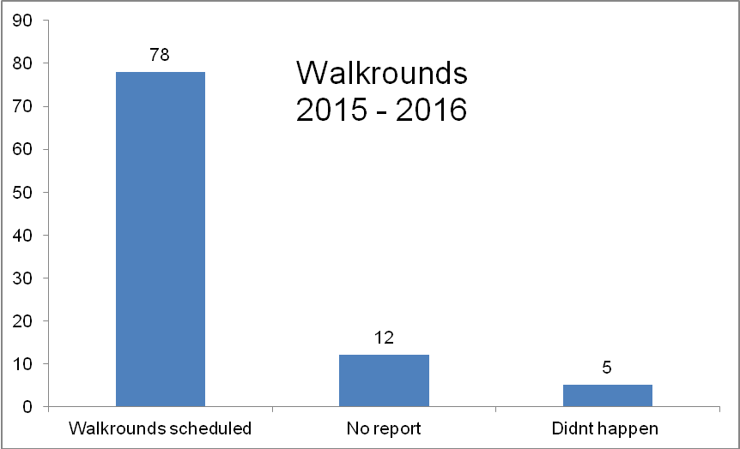 | A session to refresh the expectations of the walkround team will be held to restore a sense of ownership for the Executive leaders and managers.
  Critical Care (ITU) | The last VAP was in January 2015.  The last central line infection in 2013. | The ITU team will continue to monitor outcome measures (which are collected via national ICU reports).
  Theatre Measures | No outcome data is collected for theatres for SPSP. Two of the essentials of safety measures have been collected since the inception of SPSP (compliance with safety brief and pause). Data has shown that these are reliably done in theatres (this data is captured on SAPPHIRE, the theatre reporting system. An operation cannot proceed on the system until this box has been completed). | Dr Love, Associate Medical Director for Clinical Governance and Quality and Consultant Anaesthetist is leading a quality improvement piece of work on the quality of the safety briefs and pauses and developing a measure of quality for these briefs and pauses.
  General Ward Measures | All inpatient wards in the BGH collect and self report the above measures on a monthly basis, and have done so since the inception of SPSP. The process measures are all reported back to the wards via the Senior Charge Nurse dashboards, and displayed on the ward information boards.
  Hand Hygiene | 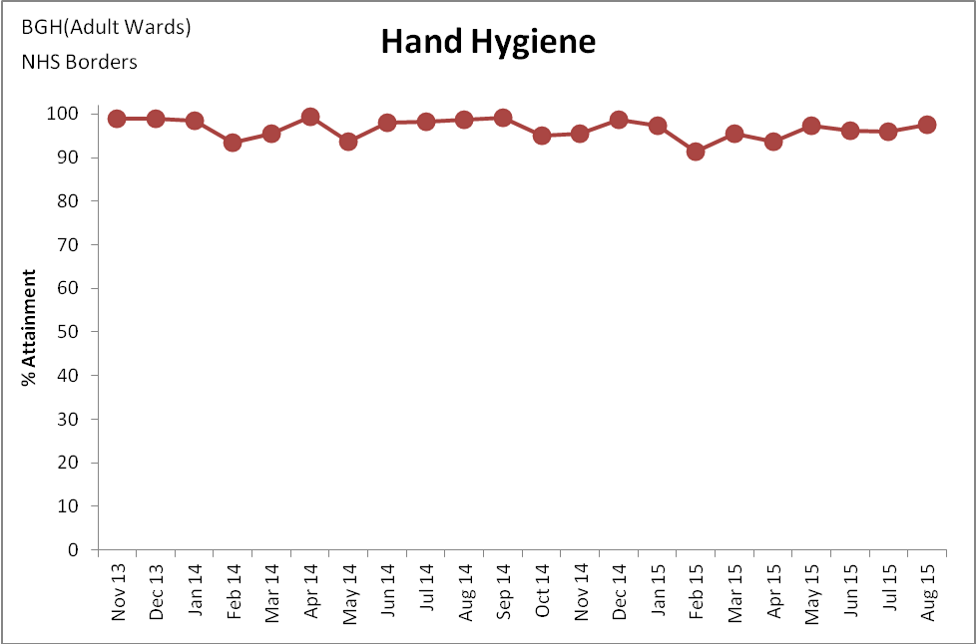 | SPSP no longer requires data submission but the Scottish Government continue to ask the Infection Control team to submit the data on a monthly basis.
  General Ward Safety Briefings | The data shows reliability with the daily ward safety briefings taking place on a daily basis in inpatient areas. | The plan for an improvement focus will be on handovers which will incorporate a measure of quality for the safety briefs.
  Peripheral Vascular Cannula (PVC) Maintenance Bundle | The data shows reliability with PVC maintenance bundles across all inpatient areas. | This process measure will remain at the fore of the Clinical Nurse Managers (CNM) assurance methods on the wards, and become an element of the Senior Charge Nurse Health Records Audit Tool and part of the Older People in Acute Hospitals (OPAH) core nursing documentation.
  Deteriorating Patient Workstream | The outcome measure for deteriorating patient is the reduction in cardiac arrests. This is achieved through a collection of measures such as identification, escalation and treatment of the deteriorating patient.
  Cardiac Arrest | 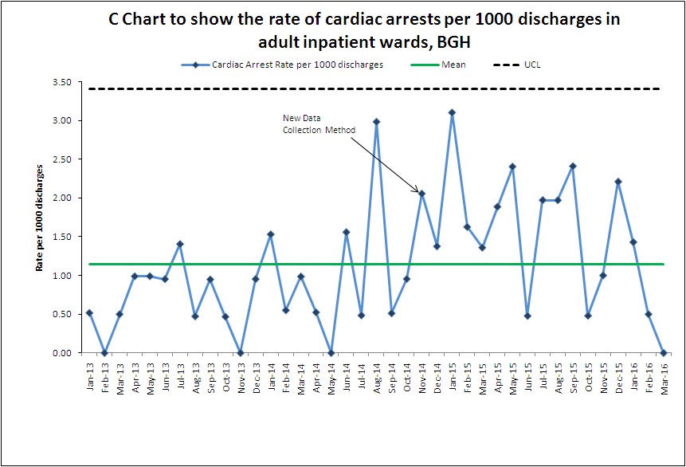  The target set by Health Improvement Scotland is 300 days between cardiac arrests based on the theory that cardiac arrests are generally preventable, and rare events. For BGH data please see chart 6 of areas where 300 days has been achieved:  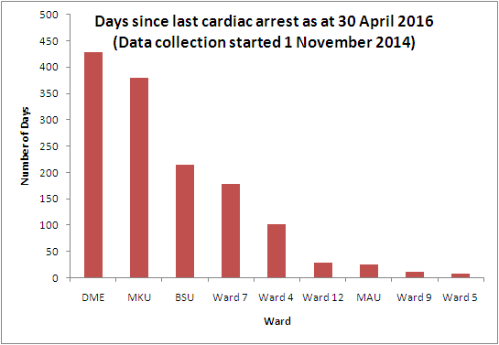 | The data collection method changed in November 2014 to ensure robust data submission. It is essential to have this data in view of the change in early warning scoring system, and it will be continued to be collated in this way.
  Crash Calls | 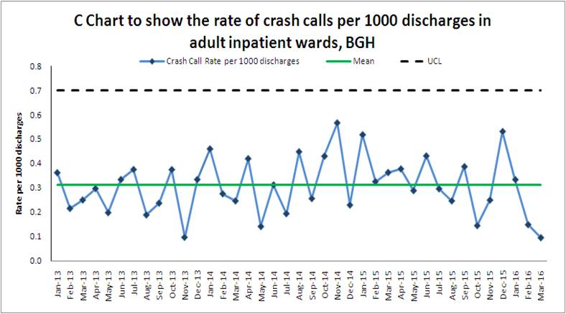 | As part of the deteriorating patient workstream, debriefs on cardiac arrests will be incorporated in to the daily hospital huddle, with an emphasis on sharing the learning across sites. This will facilitate improved understanding of cardiac arrest incidence and escalation of deteriorating patient.
  Early Warning Scores | Current data shows high reliability with this process measure across all inpatient areas. | It has been agreed that the frequency and accuracy of early warning scores continue as a means of accurately  monitoring the changeover of early warning scoring systems, which occurred in November 2015.
  Handovers | A side effect of the introduction of National Early Warning Score (NEWS) has shown that the SBAR tool (situation, background, assessment and recommendation) is not reliably used throughout the Organisation when calling either the Hospital at Night team or the Critical Care Outreach Team for assistance. | It has been agreed that the focus of safety improvement work for 2016/17 will focus on ensuring SBAR communication is implemented reliably, with particular emphasis on handovers.
  Structured Review and Response | These two measures are not currently measured in NHS Borders. | It has been agreed, that in line with the Connected Care programme, some testing work for these measures will commence.
  Sepsis | The sepsis six bundle performance data show reliability in the Emergency Department, and variation elsewhere. | This will remain a priority for 2016/17and a junior doctor has volunteered to reinvigorate this workstream.
  DNACPR (Do Not Attempt Cardiopulmonary Resuscitation): | Through the daily OPAH work currently being undertaken, improvements are being made in DNACPR form completion and accuracy. | Following the publication of guidance from the Resuscitation Council, the British Medical Association and the Royal College of Nursing, whilst not forming part of SPSP, NHS Borders will undertake improvement work with the aim of 95% of patients who have DNACPR have documented evidence of effective patient/ family involvement (including reasons for not doing so).
  Medicines | 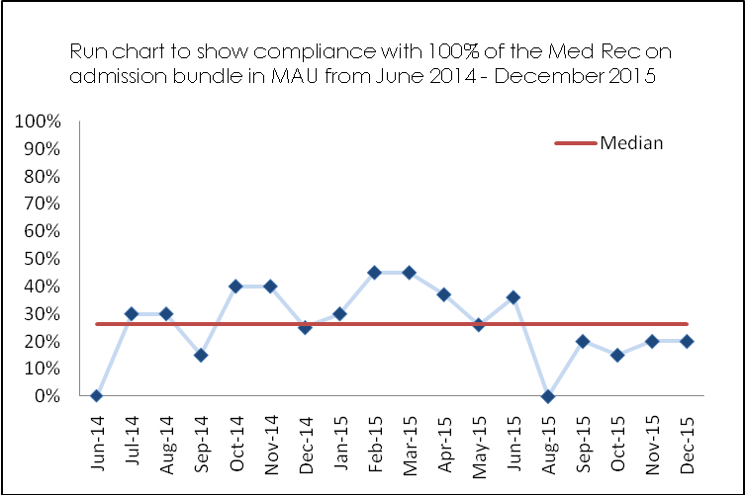 | Input from a pharmacist on Medical Admission Unit (MAU) has enabled the data to be collected and some tests of change to take place. A weekly multi disciplinary huddle is now taking place to drive improvement of medicines reconciliation in MAU.
  Red Allergy Bands | Whilst not a component of SPSP, the testing work was undertake in ward 7 and has proved to be both popular and effective with staff and patients alike. It has been agreed to roll out the red allergy bands throughout the BGH and Community hospitals, and that the pharmacy department will assist in this process.
  Pain Scores | Following on from recent complaints and significant adverse events, improvement work focusing on pain scores has been highlighted as requiring focus within the BGH. Pain scores have been included on the NEWS chart, whilst not forming part of the NEWS score, are an essential assessment. In conjunction with feedback from Complaints, it has been agreed that ongoing auditing of pain scores with a drive to embedding this process in to nursing assessments which will form part of the safety agenda for the forthcoming year.
  Heart Failure | The Heart Failure Bundle has been present on the measurement plan since the inception of SPSP. NHS Borders reliably uses the bundle for every heart failure patient identified every time they are admitted to the BGH. It has been agreed to step down this measure.
  Venous thrombo-embolism (VTE) | VTE will not be a core measure for the revised SPSP measurement plan; instead it will be an optional supplementary measure. Data continues to be collected by the Clinical Governance and Quality Safety Team in the pilot ward (ward 16) but minimal improvements are being tested. NHS Borders have led the way by now having the risk assessment on the medicines prescription chart, but completion of the assessment remains poor by medical staff. Nationally, buy- in has remained poor throughout the programme, partly due to the lack of outcome data. Dr Watkin (Consultant Physician), Ali Mather (5th year medical student) and Julia Scott (Clinical Governance Facilitator) attended an interview at HIS in January and were successful in succeeding in being given funding to recruit an Improvement Advisor (Band 7, full time for one year) to concentrate on VTE in NHS Borders. This post will be nationally recognised and lead the way in diagnosing, testing and implementing a suite of measures for VTE. Recruitment of a suitable candidate is in process.
  Falls | The second phase of the Scottish Patient Safety Programme (SPSP) aims to achieve a 25% reduction in all falls and 20% reduction in falls with harm in acute in patient care, while promoting recovery, independence and rehabilitation. Falls measures form an integral part of the revised measurement plan.  Locally, falls process and outcome measures form part of the Senior Charge Nurse dashboards and data is displayed in the inpatient areas.
  This chart includes minor, major, moderate and extreme falls as categorised on the risk management system) | 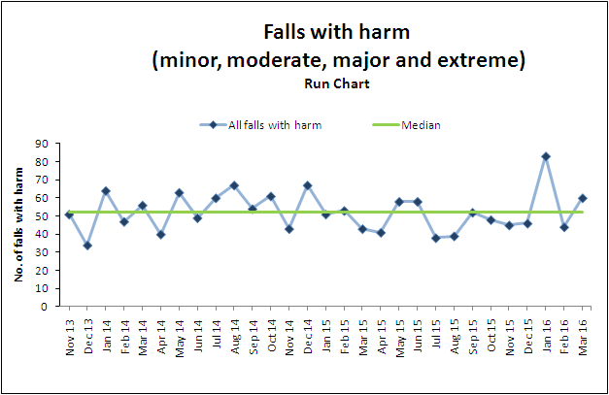 | As one of the four priority areas for the Nursing Directorate and of (OPAH) workstream, it has been agreed that the Clinical Improvement Facilitators and Practice Education Facilitator will continue to undertake tests of change and quality improvement in the areas with the highest numbers of falls, whilst triangulating the outcome data with process data and reported events.
  This chart includes major, moderate and extreme falls as categorised on the risk management system) | 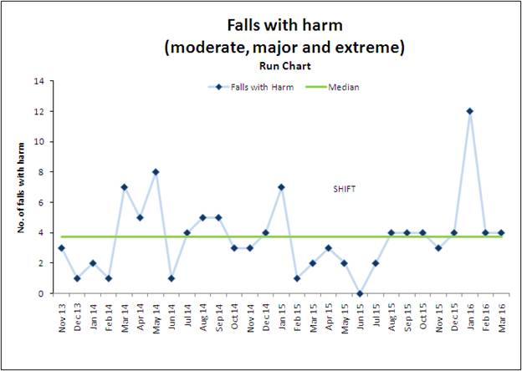
  Pressure Ulcers | The following graph demonstrates all new grade 2 and above pressure ulcers acquired after admission/transfer to a BGH in patient area where assessment and clinical history did not ascertain damage had started prior to admission:  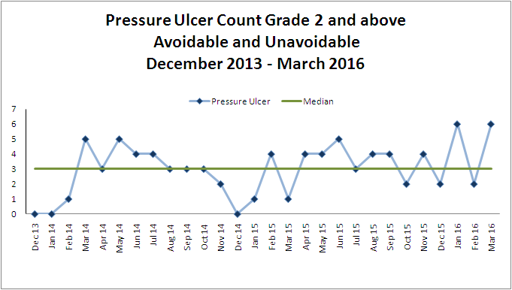 | Again, as one of the four priority areas for the Nursing Directorate, it has been agreed that the clinical improvement facilitators continue to undertake quality improvement in this area, whilst triangulating the outcome data with process data and reported events. They will be holding practice reviews following reporting of a pressure sore with the staff on the ward, to ensure real time, immediate improvements are made.
  Catheter Acquired Urinary Tract Infection (CAUTI) | The Scottish Government funded a Healthcare Acquired Infection Quality Improvement Facilitator in each Health Board to focus specifically on the CAUTI workstream in 2015. This funding has now come to an end. Early testing of outcome data in the adult acute inpatient setting (ward 12) has revealed a very small number of CAUTI.  It has been agreed that the Infection Control team will to monitor CAUTI in the pilot ward. The patient passport, containing the insertion and maintenance bundles have been rolled out in BGH and Primary care but compliance remains poor, therefore the Clinical Nurse Managers have been asked to reinforce this process.
Deliver safe, effective and high quality services | Communicate – listen to patients and ask ‘what matters to you’ | Health in Your Hands – what matters to you?  NHS Borders is committed to working with people who use our services to ensure that future delivery of services meets the needs and expectations of our communities.  The NHS Borders Health in Your Hands: what matters to you? engagement exercise was launched at its Annual Review on 17th September 2015 and concluded on 24th March 2016. We have had recorded 716 unique conversations with people across the Borders underlining the valuable contribution that our public can offer. This engagement exercise has served not only to inform specific projects and service improvements but also to invited feedback and discussion around all areas of interest to our communities.  We recognise that our communities should be seen as co-owners and partners in our NHS rather than as service-users. We are committed to the concept of mutuality and co-ownership with the people of the Borders and will strive to improve inclusion and public involvement in designing and improving services.  The questions asked were during what matters to you? were:  - Tell us about your experience of using NHS Borders?  - What we can do together to improve health services for our communities?  - Looking to the future of healthcare services in the borders, where should our focus be?  The exercise involved a combination of informal and targeted engagement techniques and approaches. Examples of some of the activities planned are below:  Informal  Engaging the public in conversation in informal settings such as local cafes and supermarkets.  Targeted – seldom heard and hard to reach groups.  We used a targeted approach, such as focus groups, to have meaningful and more structured engagement with specific groups and on specific issues. The contributions from the focus groups has provided additional valuable feedback with contributors stating they felt freer to talk and share their views, and they have had the time and safe space to articulate their views.  We worked with our colleagues across health, social care and third sector to identify existing community groups that we can reach out to. For example, we actively engaged with carers groups across the Borders.  During the engagement our online presence was increased due to the use of the #WMTYBorders across our social media channels and the @NHSBorders twitter account. The WMTY micro-site on the staff intranet provided regular updates of where we were in the final few weeks of our engagement.  The feedback received during the engagement exercise is now being collated and considered and a final summary report will be presented to the Board in June 2016.
Deliver safe, effective and high quality services | Strive to meet and exceed the performance targets set for us by the governments and our own board | Strong performance management remains a key priority across all areas of NHS Borders. Performance Scorecards and Performance Reviews continue to be embedded across all services with compliance monitored. Current reporting arrangements have been reviewed and sense checked as to whether the needs and requirements of the Board are being met. It has also been an opportunity to take into account any changes in reporting requirements as a result of Health & Social Care Integration and the establishment of the Integrated Joint Board. By reviewing the current reporting framework we have been able to seek out opportunities which will reduce duplication, provide greater alignment and focus on LDP standards and targets and ensure a more consistent and standardised approach which will be introduced during 2016/17.
Deliver safe, effective and high quality services | Run an efficient organisation by living within our means and concentrating resources on front line services | A key element of the Board’s plan to attain a financial breakeven in 2015/16 was the achievement of its cost efficiency target. During the financial year £6.9m of savings were delivered and the target was fully achieved. It became clear during the financial year that a number of recurring efficiency schemes would not release resources as planned in 2015/16 therefore a number of non recurring resources were identified. The use of these non recurring measures although ensuring the overall target has been achieved means NHS Borders will be entering 2016/17 with a recurring deficit of £1.7m. This will increase the level of challenge required in an already difficult financial outlook.  In support of the corporate objectives during 2015/16 NHS Borders undertook the following work:  - Progressed the Roxburgh Street Replacement Surgery in Galashiels with Procurement Partner Stage 1 approved and ongoing work on Stage 2 detailed design and construction contract. This included the demolition of the former Ambulance Station on the site for the new build which is anticipated will start in May 2016.  - Completed an upgrade, reconfiguration and provision of additional accommodation at Selkirk Health Centre.  - Further progressed the Board's Estates Rationalisation Programme with the disposal of 2 properties - West Grove, Melrose and 12-14 Roxburgh Street in Galashiels. The Board also relocated services from 2 rental properties to the Board owned property.  - Completed a significant IM&T Active Directory and Desktop Transformation Project covering the Borders General Hospital and all General Practitioner Health Centre sites.  - Relocated the Community Mental Health Teams and the MH Crisis Team onto the Huntlyburn site in Melrose.  - Upgraded the Mental Health Inpatient Ward at Melburn Lodge  - Undertook detailed design work for the planned replacement of the Theatre Ventilation Units at Borders General Hospital.  - Made continuing investment in rolling replacement programmes of work on the Boards Estate and Medical Equipment
Improve the health of our population | Work with communities and our partner organisations in Scottish Borders Council and the Third Sector | The Borders Director of Public Health report published in late 2015 sets out key issues for the health of the population and gives examples of collaborative work to improve health, involving a range of partner organisations and local communities. This work ranges across all age groups: involvement of the Health Improvement team in activities within the Early Years Centres on healthy eating and nutrition, delivering a series of Bump to Baby events across all localities for expectant and new parents, with the active involvement of many other services; continuation of the Fit4fun schools-based programme on healthy and active living; working with the youth sector on healthy and respectful relationships; facilitating and supporting community groups with the development of skills knowledge and confidence to take steps to improve health.  Collaboration with the third sector has been strong and is set to continue in 16 -17 in significant areas such as mental health, supporting people with long term conditions, engaging with migrant communities and local alliances for food and health.  Through the Reducing Inequalities strategy Public Health is facilitating collaboration on health inequalities, recognising national priorities and using local intelligence to target needs. Following a workshop for partners in October 2015, partners have agreed priorities for reducing health inequalities. These priorities will be informing service planning and delivery across health and social care and children and young people’s services.  Health improvement programmes including smoking cessation, mental health, nutrition and physical activity and the Healthy Living Network are targeted on high need related to small area deprivation or other factors associated with inequalities.
Improve the health of our population | Harness the assets of our communities to encourage and facilitate self-help
Improve the health of our population | Target the most deprived areas of the Scottish Borders to reduce inequalities
Improve the health of our population | Promote well-being with a strong focus on the healthy development of children | Considerable work has progressed to ensure a robust implementation of the Children and Young People’s Act (2014) with a focus on parts 4,5 and 18 in relation to the implementation of GIRFEC around Child’s Plan, Named Person Service and Wellbeing. The Named Person Service will be implemented across the partnership on 31st August 2016 in line with the implementation date of the Act. All Health Visitors and Family Nurses have received Named Person Training. The Children’s Planning Manual has been developed as a virtual document and will be accessed by all staff through an Office 365 site hosted by the Local Authority. We have trained GIRFEC Champions in Health who will provide support and signposting for health staff as issues or questions arise related to the Act. The Champions have an enhanced understanding of the GIRFEC process. In addition three NHS staff have completed a two day GIRFEC Train the Trainers Master Class and are delivering session across health.  Work is underway around the implementation of the Health Visiting Pathway and Health Visitors and Family Nurses are starting antenatal visits in line with the pathway. We have been able to recruit and train additional Health Visitors to support the named person service and HV Integrated Pathway and by 2018 will have an additional complement of 10 Health Visitors. Unlike other areas we have had no issue with recruitment.  We have had a Joint Inspection of Children’s Services by the Care Inspectorate which commenced in September 2015 and the report published in June/July 2016.  We have recently launched a new Integrated Children’s Plan across the partnership which clearly sets out the priorities for Children in the Borders with an overarching theme of reducing inequalities.  Scottish Borders has an above average uptake of child health reviews of young children at 27-30 months of age, with this being the third highest area in Scotland. 81% of children assessed in 2014/15 were meeting their developmental milestones which were greater than the Scottish average of 72  In relation to dental health in 2015, 77% of children in primary 1 were assessed as having no obvious sign of decay. This compares well to the national average of 68% and is the second highest in Scotland. For primary 7 children, 84% had no obvious sign of decay in their permanent teeth, greater than the national average of 75% and the highest figure in Scotland. There had been a steady upward trend over the past decade. Dental registrations are an indication of the accessibility of preventative dental care. In Scottish Borders the rate of dental registration for children was 88%, in line with the national rate. Positively, children in Scottish Borders had the highest participation rate (regularly attending the dentist) in Scotland in 2015 for attending the dentist.  Breastfeeding rates for those babies exclusively breastfed were increasing. In 2014/15, 34.5% of babies were exclusively breastfed at the 6-8 week review; a rise of 5.3% since the UNICEF Baby Friendly Initiative had been implemented in Scottish Borders. This is greater than the figure for Scotland of 27.3%.  95% of young children were fully immunised. The highest uptake in Scotland of flu vaccine in primary schools has been achieved.
Promote excellence in organisational behaviour | Be an excellent employer and become employer of choice | During 2015/16 NHS Borders has sought to embed the organisation’s values across the work of the organisation, in order to offer assurance that staff not only lived and demonstrated these values in the workplace but that they would be supported and encouraged to do so. To ensure that we attract the right people, the values of NHS Borders have been added to the recruitment bulletin and advertisements. A Behavioural Framework was developed which is now sent to all candidates to allow recruiting managers to be more assured about the “fit” of candidates. Testing of the framework continues but managers and members have staff have consistently reported that they find this a useful and user friendly tool. This has now been tested on all staff groups and levels. Existing recruitment frameworks were adapted and tested to allow this to be more specifically linked to NHS Borders values. An exercise to allow evidencing individual’s ability to implement the behaviours linked to our values was introduced successfully in the nurse recruitment event in September, 2015. Both interviewers and interviewees reported that this was extremely useful.  Whilst carrying out this work it became apparent that many of our existing job descriptions and person specifications required updating and made more robustly linked to competencies and values. There was also a desire to consider developing generic Agenda for Change job descriptions. This work will be progressed throughout 2016. HR is asking managers, as they commence recruitment to assure themselves that the job descriptions and person specifications are of good value. It was also clear that manager needed more information on Values Based Recruitment and their responsibilities linked to it. To address this issue work is currently being progressed to refresh the current recruitment area on the Intranet (giving managers an electronic toolkit) and develop a recruitment area on NHS Borders Internet page. This would also give us the ability to “sell” the organisation more to prospective candidates. Letters within HR have been amended to reflect the Values Based Recruitment approach. Within the toolkit there are also tools on short listing, interviewing and selection. Values Based Recruitment was fully implemented on the 1st of April, 2016 after a period of extensive testing.  The values are also being used as a core part of the Corporate Induction process for new staff. In particular, Care and Compassion (How we treat our patients) and Dignity and Respect (How we treat each other) as the golden threads that wove together not only in Induction but in all Training and Development opportunities. A key component part of the new Induction program was to use a patient story. These stories have consistently been cited as powerful learning experiences for those attending. During the period between September, 2015 and February, 2015 the program and its content was modified significantly. More use of visual aids (DVD/ stories) had been indicated from the results of the previous PDSA cycles and this was addressed. Individuals reported an increased awareness of the impact that their behaviour had on patient/carers and their colleagues. It appeared that the impact had moved from purely giving knowledge (increasing awareness of values/support mechanisms) to making people feel the values.  The third and final cohort has recently been commenced in the roll out of iMatter. The Board continues to perform well with a 67% response rate and an Employee Engagement Index score of 73%. Information session, road shows and pop up exhibitions have been held to continue to engage and inform staff about the iMatter programme and what it means to them. Actions for NHS Borders as a Board are being taken forward through the staff governance action planning process. We are also running sessions for managers and providing support for their team feedback and action planning. The system allows overview of response rates, action planning, completed plans. All of this information is fed back through Area Partnership Forum and Staff Governance Committee.  The Board continues to perform well nationally against the HEAT standards for implementation of eKSF, Appraisal and PDP but continues to show a declining performance against the previous year. Work will be taken forward by the Staff Governance Committee and APF to address this.
Promote excellence in organisational behaviour | Value and treat our staff well to improve patient care and overall performance | As part of the continuation of values based employment, different methods of staying in touch with new members of staff have been considered. As part of the scoping work a dedicated Notice Board for General Service’s staff has been identified. This is now being utilised successfully by the Facilities Manager and addresses the issue of communicating with a group of staff who have little or no access to internet. The Chief Executive has very effectively engaged directly with a group of Senior Charge Nurses to empower them to support and deliver a more positive culture within their ward areas. They are working to deliver a more positive culture linked to the golden threads of Customer care and Compassion and Dignity and Respect.  An extensive exercise has also been carried out which identifies the existing training capacity with the Organisation. This will be further developed in the work currently underway which is evaluating Mandatory and Statutory training within NHS Borders. The desired outcome will be that the “golden threads” will be woven throughout all training and development opportunities.  The need to test, adapt and implement robust/measurable methods of keeping in touch should be progressed. We should also continue to consider the use of Coaching as part of the “On Boarding and beyond” process and test different models of measuring behaviours within the work area.  Work is yet to commence in ensuring that all local Inductions are consistent and linked to the golden threads. The existing Mandatory and Statutory Training Policy will need to be adapted to reflect this ongoing work and to ensure the work becomes fully implemented there is a need to link the golden threads explicitly within the Appraisal and Personal Development programme.
Promote excellence in organisational behaviour | Promote and engage leadership through:  - Supporting a developmental culture  - Showing genuine concern  - Enabling  - Inspiring others | The Organisation has, for the third year, recognised and awarded employees for their exceptional leadership. At this year’s Celebrating Excellence event 3 staffs were shortlisted for the Leading by Example award. The winner was selected as an inspiration to her team and someone who is held in the highest regard by all who work with her. Dedicated, enthusiastic, passionate and a boundless source of energy and enthusiasm. Innovative in her thinking and always exploring new ways to improve services.  The Board has continued to develop in line with the outcomes from the 360° self appraisal conducted in the previous year and also proposes to complete the national Board Diagnostic Tool to feed into what has already been identified.  Work has continued in ensuring that the Engaging Leadership strands are woven into the fabric of all leadership and management training locally with the Engaging Leadership Culture Grid diagnostic being used to support this. A group of experienced line managers have continued to support First Line Manager training by providing coaching to participants, as well as further developing their own coaching practice. A review of this and other leadership and management training is commencing to ensure that the organisational values are explicitly linked to future development opportunities This will also allow for closer working with a wider partner group in the Scottish Borders.  The Workforce Conference – entitled “Living Our Values” was held on 11 March 2016. The conference featured a key note speech and break-out session on “implementing our values”. 55 members of staff, from a range of staff groups and areas of work, attended. The Conference evaluated well with all attending rating the event as good or very good. They also considered the event to be high on the scale of inspiration.

