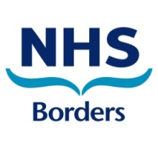

Welcome to
National Health Service (NHS) Borders

Version 2 – Updated 28 July 2022

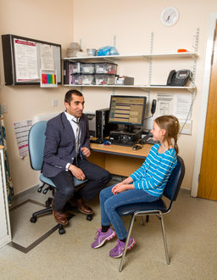
General Practitioners within
NHS Borders

In Scotland, family doctors are often called General Practitioners or GPs. They work in GP surgeries, medical practices or health centres. General Practices are open and available for your health and wellbeing needs.

Medical services provided by General Practices are free for everyone regardless of citizenship status. General Practices may charge you to complete various letters and certificates that are not provided by the NHS.

You need to find a family doctor as soon as possible after you arrive in Scotland and ask them to register you as an NHS patient. Below is a list of all the GPs in the Scottish Borders:

GP Practice Name & Address | Phone Number
Merse Medical Practice, South Crofts, CHIRNSIDE, TD11 3XP | 01890 818 253
Coldstream Medical Practice, Kelso Road, COLDSTREAM, TD12 4LQ | 01890 882 711
Merse Medical Practice, Station Road, DUNS, TD11 3EL | 01361 885 030
Duns Medical Group, The Knoll, Station Road, DUNS, TD11 3EL | 01361 885 040
Earlston Medical Practice, Kidgate, EARLSTON, TD3 6DW | 01896 848 333
Eyemouth Medical Practice, Houndlaw Park, EYEMOUTH, TD14 5DD | 01890 750 599  01890 750 383
Waverley Medical Practice Centre, Currie Road, GALASHIELS, TD1 2UA | 01896 661 350
Braeside Medical Practice, Currie Road, GALASHIELS, TD1 2UA | 01896 661 360
Ellwyn Medical Practice, Currie Road, GALASHIELS, TD1 2UA | 01896 661 355
Glenfield Medical Practice, Currie Road, GALASHIELS, TD1 2UA | 01896 661 363
Roxburgh Street Surgery, Roxburgh Street, GALASHIELS, TD1 1PF | 01896 752 557
Greenlaw Surgery, Duns Road, GREENLAW, TD10 6XJ | 01361 885 161
Teviot Medical Practice, Teviot Road, HAWICK, TD9 9DT | 01450 370 999
The O’Connell St Medical Practice, O’Connell Street, HAWICK, TD9 9HU | 01450 372 276
St.Ronan’s Health Centre, 1 Buchan Place, INNERLEITHEN, EH44 6QE | 01896 830 203
Jedburgh Medical Practice, Queen Street, JEDBURGH, TD8 6EN | 01835 863 361
Kelso Medical Group Practice, Health Centre, Inch Road, KELSO, TD5 7LF | 01573 224 424
Stow & Lauder Health, Crofts Road, LAUDER, TD2 6QJ | 01578 718 670
Eildon Surgery, St Dunstan’s Park, MELROSE, TD6 9RX | 01896 822 161  01896 822 945
Newcastleton Medical Practice, Moss Road, NEWCASTLETON, TD9 0RU | 01387 375 100
The Neidpath Practice, Neidpath Road, PEEBLES, EH45 8JG | 01721 720 380
The Tweed Practice, Neidpath Road, PEEBLES, EH45 8JG | 01721 720 601
Eildon Surgery, Auction Mart, NEWTOWN ST BOSWELLS, TD6 0PP | 01835 822 777  01835 823 629
Selkirk Medical Practice, Viewfield Lane, SELKIRK, TD7 4LJ | 01750 216 74
Stow & Lauder Health, Station Road, STOW, TD1 2SQ | 01896 661 440  01896 661 441
West Linton Medical Practice, Deanfoot Road, WEST LINTON, EH46 7EX | 01968 660 808

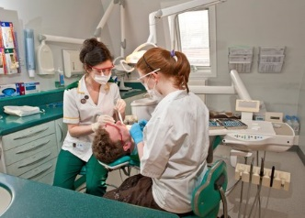
Dental Services within NHS Borders

You need to find a dentist as soon as possible after you arrive in Scotland and ask them to register you as an NHS patient. Free NHS dental care is available to displaced persons from Ukraine. Please note that not all dental practices currently have spaces for NHS patients so you may need to contact more than one practice. Below is a list of all the dentists in the Scottish Borders:

Dental Practice Name & Address | Phone Number
Duns Dental Practice, 40 Market Square, DUNS, TD11 3AL | 01361 882262
The Eyemouth Dental Practice, Old Telephone Exchange, Upper Houndlow, EYEMOUTH, TD14 5BU | 018907 50519
My Dentist, 23 Albert Place, GALASHIELS, TD1 3DL | 01896 752679
Bank Street Dental Practice, 19 Bank Street, GALASHIELS, TD1 1EN | 01896 752752
Borders Orthodontics, Market Street, GALASHIELS, TD1 3AF | 01896 759331
Roxburgh Dental Practice, 54 Ladhope Vale, GALASHIELS, TD1 1BT | 01896 661122
North Bridge Dental, 41 Bridge Street, HAWICK, TD9 9PX | 01450 372187
GK Dental, 54 High Street, HAWICK, TD9 9EE | 01450 371777
Teviot Dental Practice, 20 North Bridge Street, HAWICK, TD9 9QW | 01450 372476
Jedburgh Family Dental Practice, Jedburgh Health Centre, Queen Street, JEDBURGH, TD8 6EN | 01835 863247
EM&B Dental Practice, 11 High Street, JEDBURGH, TD8 6AH | 01835 862234
The Gentle Touch Dental Practice, The Corn Exchange, 31 Woodmarket, KELSO, TD5 7AT | 01573 224802
Peebles Dental Practice, 36 High Street, PEEBLES, EH45 8SF | 01721 720532
Kingsmeadows Dental Practice, 7 Kings Meadows Road, PEEBLES, EH45 9EN | 01721 722320
Cherry Court Dental Care & Implant Clinic, 3 Cherry Court, Cavalry Park, PEEBLES, EH45 9BU | 01721 724375
Rosalind Kerr Dental Surgery, 11 Elm Court, Cavalry Park, PEEBLES, EH45 9BU | 01721 720574
Selkirk Dental Practice, 25 West Port, SELKIRK, TD7 4DG | 01750 21793

You should contact your dentist if you have any pain or problem in your mouth that you want to have checked. This includes mouth injuries and ulcers that won’t heal. Access to care will be determined based on your clinical need.

If you have an urgent dental problem while your dental practice is closed, you can contact NHS 24 for free by telephoning 111.

If you’re not yet registered with a dentist, you should phone the Borders Dental Helpline on 0300 7900 710. This phone line is open Monday to Friday, 8:30am to 6pm.

Optometrists within NHS Borders

If you have an eye problem you should always contact an optometry practice (opticians) in the first instance. The majority of eye conditions can be managed by optometrists, who are highly skilled clinicians. If your optometry practice is closed and you’re concerned about your vision, telephone NHS 24 for free on 111.

Free NHS eye examinations are available to all UK residents including those displaced from Ukraine. It’s important that you have your eyes regularly examined, even if you’re not worried about your vision, to help early detection of eye problems and signs of other health conditions. If necessary, your optometrist can refer you for any further help you need. You may also be entitled to help towards the cost of glasses or contact lenses in the form of an NHS optical voucher.

To make an appointment, please contact one of the optometrists from the list below:

Optometrists Name & Address | Phone Number
Boots Opticians, 88 Channel Street, GALASHIELS, TD1 1BD | 01896 752728
Boots Opticians Hawick, 25 High Street, HAWICK, TD9 9BU | 01450 372333
Concept Eye Clinic, The Old Smithy, 3 The Wynd, MELROSE, TD6 9LD | 01896 823223
Hall Opticians, 26 Bank Street, GALASHIELS, TD1 1EN | 01896 755891
Higgins Opticians, 29 High Street, PEEBLES, EH45 8AN | 01721 588006
McClean Optometrists, West Linton Medical Practice, Deanfoot Road, WEST LINTON, EH46 7EX | 01968 660808
Noel Johnston Opticians, 9 Market Square, DUNS, TD11 3DB | 01361 882800
2020 Opticians, 43 Northgate, PEEBLES, EH45 8BU | 01721 721151
RD McFarlane Opticians, 10 West Port, SELKIRK, TD7 4DG | 01750 21721
Specsavers, Unit 3A, 7 Douglas Bridge, GALASHIELS, TD1 1BH | 01896 661470
The Opticians, 2 Howegate, HAWICK, TD9 0AB | 01450 372629
The Opticians, 39 High Street, JEDBURGH, TD8 6JW | 01835 862777

Community Pharmacies within
NHS Borders

If you have a minor illness, a local pharmacy should be your first stop. Your local pharmacy can help with:
- Advice and treatment for minor illnesses and common conditions like colds, cold sores, sore throats, diarrhoea, constipation, shingles, skin infections and for women, urinary infections.
- Your repeat prescriptions.
- Access to free emergency contraception.

Everything you discuss with your pharmacist is confidential and if required, your pharmacist can signpost you to another healthcare professional. Below is a list of all the pharmacies in the Scottish Borders:

Community Pharmacy Name & Address | Phone Number
GLM Romanes Ltd, Crosshill, CHIRNSIDE, TD11 3XW | 01890 819809
GLM Romanes Ltd, 45 High Street, COLDSTREAM, TD12 4DL | 01890 882412
GLM Romanes Ltd, 1-3 Market Square, DUNS, TD11 3DB | 01361 883753
M Farren Ltd, The Pharmacy, The Square, EARLSTON, TD4 6DB | 01896 849260
GLM Romanes Ltd, 6 Church Street, EYEMOUTH, TD14 5DH | 01890 750374
Boots the Chemist, Unit 4, Gala Water Retail Park, GALASHIELS, TD1 3AP | 01896 750594
Lloyds Pharmacy, 51 Channel Street, GALASHIELS, TD1 1BN | 01896 755948
Tesco Pharmacy, Paton Street, GALASHIELS, TD1 3AT | 01896 461125
M Farren Ltd, 23 – 24 Bank Street, GALASHIELS, TD1 1EW | 01896 752217
Borders Pharmacy, 12 Marmion Road, Langlee, GALASHIELS, TD1 2DE | 01896 756555
GLM Romanes Ltd, 4 The Square, GREENLAW, TD10 6UD | 01361 810684
Boots The Chemist, 76 High Street, HAWICK, TD9 8HS | 01450 372051
T N Crosby, 16 Bridge Street, HAWICK, TD9 9QW | 01450 372475
HHCC Pharmacy, Health Centre Teviot Road, HAWICK, TD9 9DT | 01450 377449
Lindsay & Gilmour, 5 Oliver Place, HAWICK, TD9 9BG | 01450 372757
Borders Pharmacy, 11-13 Kenilworth Avenue, HAWICK, TD9 8EG | 01450 373300
M Farren Ltd, 31 High Street, INNERLEITHEN, EH44 6HD | 01896 830384
Boots Pharmacy, 4 High Street, JEDBURGH, TD8 6AG | 01835 862418
Jedburgh Pharmacy, 22 High Street, JEDBURGH, TD8 6AG | 01835 863489
Boots The Chemist, 20 The Square, KELSO, TD5 7HH | 01573 224523
Lloyds Pharmacy, 36 – 40 Horsemarket, KELSO, TD5 7HD | 01573 224613
Lauder Pharmacy, 5 Market Place, LAUDER, TD2 6SR | 01578 722302
Boots Pharmacy, 27 – 29 High Street, MELROSE, TD6 9PL | 01896 822178
Eildon Pharmacy Ltd, Tweedside Road, NEWTOWN ST BOSWELLS, TD6 0PB | 01835 823732
Boots The Chemist, 6 – 8 Eastgate, PEEBLES, EH45 8AD | 01721 720613
Lloyds Pharmacy, 20 High Street, PEEBLES, EH45 8SF | 01721 720729
Lindsay & Gilmour, 10 – 12 Market Place, SELKIRK, TD7 4BT | 01750 21723
Right Medicine Pharmacy Ltd, 77 – 79 High Street, SELKIRK, TD7 4BZ | 01750 21230
West Linton Pharmacy Ltd, Main Street, WEST LINTON, EH46 7EE | 01968 660212
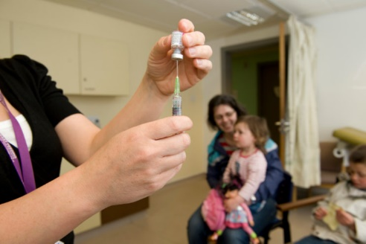
Vaccination and Immunisation
Services within NHS Borders

Immunity is the ability of the human body to protect itself from infectious disease. Vaccinations provide protection by working with your body’s natural defences to build protection against serious, preventable diseases.

What’s the difference between vaccination and immunisation? Vaccination means receiving a vaccine, having it by injection, nasal spray or oral vaccine. Immunisation means receiving vaccine then becoming immune to a disease. Vaccinations encourage your body’s immune system to produce antibodies that will fight off a virus or bacteria.

NHS Borders Vaccination Service leads the delivery of immunisation programmes in partnership with public health, school immunisation, community nursing, occupational health, maternity services, general practice, acute services and the wider Scottish Borders Health and Social Care Partnership. Please see below for contact telephone numbers for specific immunisation programmes:

- Baby & Pre-School - NHS Borders Child Health team 01896 825 531
- Schools - NHS Borders School Immunisation team 01896 661 932
- Pneumococcal - NHS Borders Vaccination Hub 01896 809 250
- Shingles - NHS Borders Vaccination Hub 01896 809 250
- Travel - NHS Borders Vaccination Hub 01896 809 250
- Influenza - National Vaccination line 0800 030 8013
- Covid 19 - National Vaccination line 0800 030 8013
- Tuberculosis – NHS Borders Vaccination Hub on 01896 809 250

Children and Family
Services within NHS Borders

Health Visiting
Health Visitors are registered nurses or midwives who have undertaken further specialist study at master’s level. They work in the community to provide a proactive and universal service to all families with babies and young children from late pregnancy until school entry. Health Visitors are healthcare specialists who contribute significantly to the well-being of children and families.

In Scotland, Health Visitors deliver the Universal Health Visiting Pathway (see diagram below) that includes a minimum of 11 contacts by the same practitioner.
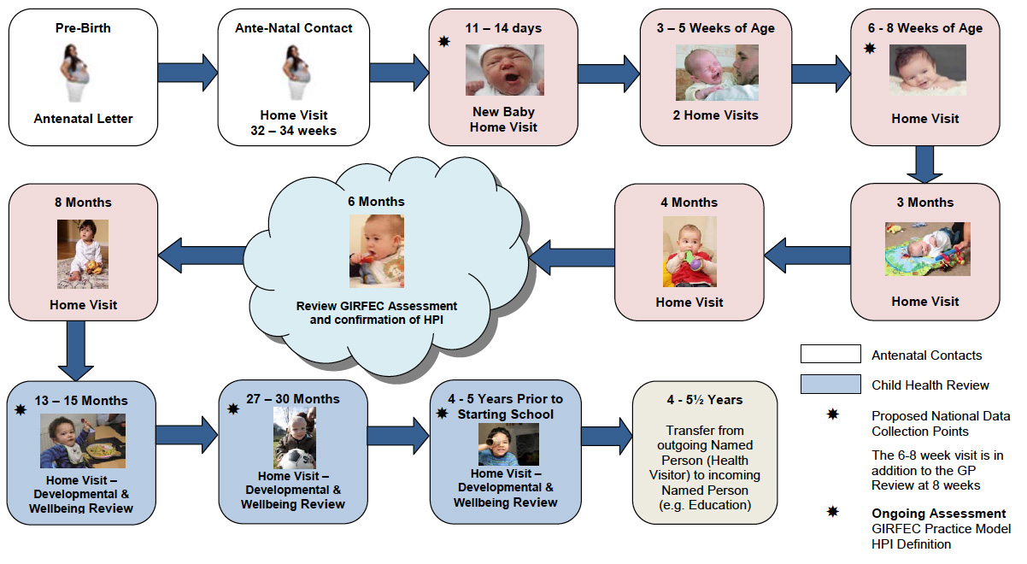
The aim of the Pathway is to build on the consistent and trusting relationship the Health Visitor develops with each family by visiting them in their own home to promote health, development, and well-being. Health visitors provide parents with support and advice so they can give their child the best possible start in life.
Health Visitors work within the Getting It Right For Every Child policy framework to tackle health inequalities and deprivation that aims to prevent children and families becoming vulnerable or at-risk with emphasis on early identification and intervention.

The proactive and health promoting focus of Health Visiting means that, particularly in the mid to later phases of pregnancy and having a new baby, services reach out to parents who may not initially have engaged with services. This way of working can potentially enhance the uptake and use of service in response to changing family circumstances. This orientation of practice will help to reduce health inequalities by responding to the needs of vulnerable and seldom heard families who require (ongoing) additional support in response to a range of special needs arising from social disadvantage or disability.

In the Scottish Borders, access to a Health Visitor will be made available to all pregnant women and children under the age of 5 when you have registered with your local GP practice.

School Nursing and School Immunisation Teams
School Nurses are registered nurses or midwives, most of whom have undertaken additional specialist training and qualifications. They work with school-aged children and young people and their families to improve health and wellbeing outcomes and reduce inequalities and vulnerabilities according to the Getting It Right For Every Child policy framework and national practice model

In Scotland, School Nurses deliver the Refocused School Nursing Pathway that is designed to support health and wellbeing for all children, whilst offering more intensive support to those with the highest needs.

All children will still be offered core services such as vaccinations (delivered locally by NHS Borders, School Immunisation Team), growth and health assessments. In addition, School Nurses will focus on young people who face additional challenges according to 10 priority areas as defined by the Scottish Government;
- Emotional Health and Wellbeing
- Substance Misuse
- Child Protection
- Domestic Abuse
- Care-experienced children
- Homelessness
- Youth Justice
- Young Carers
- Sexual Health
- Transitions (e.g., moving from pre-school to school)

To access School Nursing Services in NHS Borders:
- If you are a child or young person - Speak to your parent/carer if you feel able to do this. Alternatively, approach your teacher, guidance teacher or General Practitioner (GP)/Doctor to discuss referral to a school nurse
- If you are a parent or carer - you can speak to your child’s school, guidance teacher or GP to discuss if referral to a school nurse might help.
- Many schools have ‘drop in’ sessions where you can go and speak to a school nurse in confidence.

Accident and Emergency Care in NHS Borders

Emergency Care in NHS Borders is provided from the Scottish Ambulance Service and the Accident and Emergency Department (A&E) at Borders General Hospital. The Borders General Hospital is NHS Borders’ acute hospital, located near Melrose. It is known locally as the "BGH" and offers a range of acute inpatient services.

In an emergency you should always go directly to A&E or call 999. Our A&E services are busy so we encourage everyone to think carefully before attending. If you do go directly to A&E and it is not the most appropriate place for your care, the A&E team will first make sure you are safe before redirecting you to the best place for your treatment.

If you are unsure whether you need to go to A&E you should visit the NHSinform.scot website in the first instance. If you think you do need to go to A&E, but it is not life threatening, you should telephone NHS 24 for free on 111 first.

A&E at Borders General Hospital is open 24 hours per day, 7 days per week and is staffed at all times by medical and nursing staff. The accident and emergency department has three main functions. These are:
- to provide immediate attention to people with life-threatening problems;
- to treat patients who have injuries as a result of recent accidents;
- to assess and treat people who have been referred by a GP.
- Contact mental health services if necessary.

Borders General Hospital – Ward Contact Information

The Borders General Hospital is NHS Borders’ acute hospital, located near Melrose. Should you or a loved one be admitted to the BGH, a list of the inpatient ward contact telephone numbers is detailed below:

Ward Name | Phone Number
Medical Assessment Unit (Ward 6) | 01896 826006
Ward 4 | 01896 826004
Ward 5 | 01896 826005
Ward 7 | 01896 826007
Ward 9 | 01896 826009
Department of Medicine for the Elderly (Ward 12) | 01896 826012
Department of Medicine for the Elderly (Ward 14) | 01896 826014
Ward 15 – Noah’s Ark | 01896 826015
Ward 16 | 01896 826016
Borders Stroke Unit | 01896 826011
Margaret Kerr Unit | 01896 827919
Intensive Therapy Unit | 01896 826295

Secondary/Specialist Healthcare Services

Secondary care is specialist services/clinics to which people can go to following referral from primary healthcare services. They provide a more specialised service to patients. There are several specialist healthcare services available within NHS Borders. Examples of these are mental health services, cardiology, respiratory, orthopaedics, gynaecology, and maternity services. Access to these services is via referrals from your GP in the first instance.

